Name:  Teacher : | ____________________________________  ______________________ |  | Date:_________
 | Year 10 General  SCORE:  /31  Mini Test 9  Topic – Trigonometry  Full working out MUST be shown to get full marks for each question.
Total Time: | 35 minutes
Weighting: | 4%
Equipment: | To be provided by the student: Pen, pencil, ruler, scientific calculator, 1 single sided page of A4 notes

- Find the missing side length using Pythagoras theorem [2 + 2 = 4 Marks]

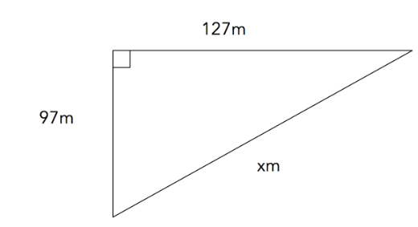  a) | 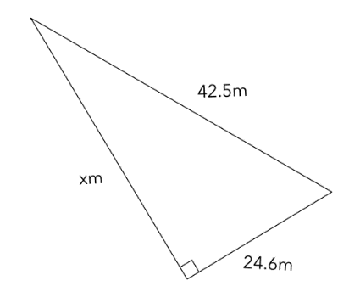  b)

- Jasmine is building a rectangular gate out of timber that is 3m long and 1.5m high. To make it strong she will need to put 2 diagonal supports. What length of timber will she need to buy in order to build the gate? hint- draw a diagram of the scenario. [4 Marks]

- Find the values of the missing side lengths to 2 decimal places [3 + 3 + 3 = 9 marks]
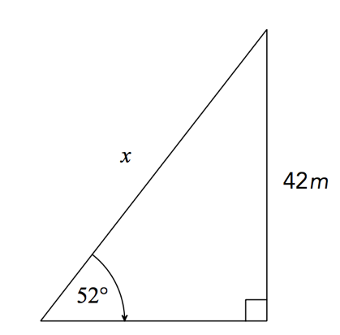
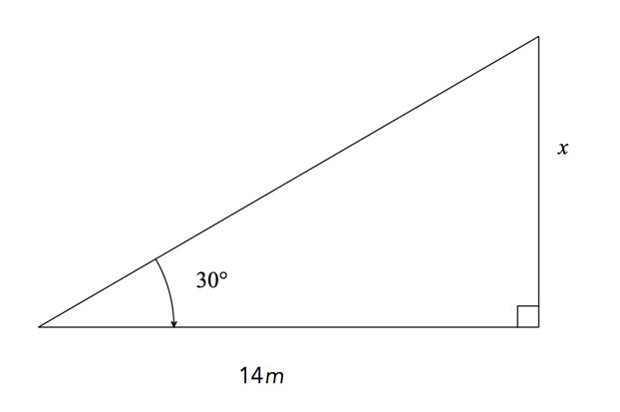

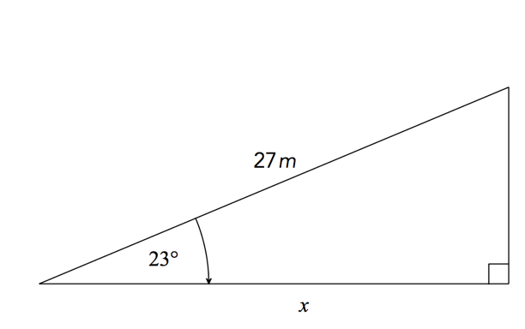

- Find the value of theta (Θ) in the two triangles below to the nearest degree [3 +3 = 6 marks]

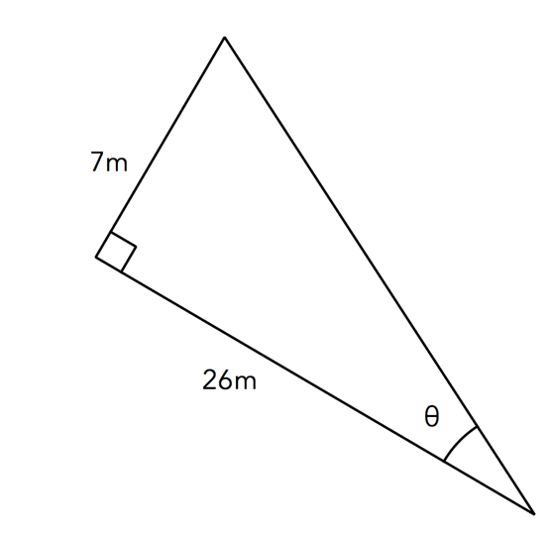
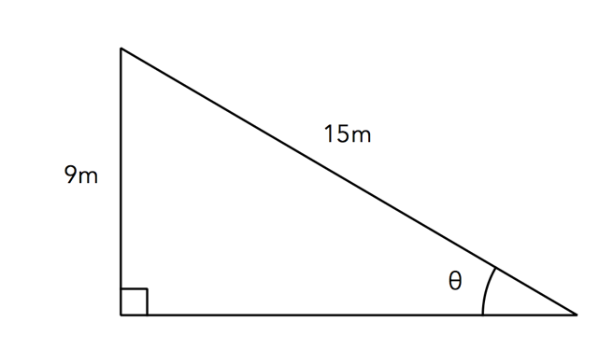

- John and Ash go camping. They park their car 30m away from the trunk of a tree. They stand next to their car use an inclinometer to measure that the angle of elevation from Ash’s eye to the tree is 53 degrees. Ash is 150cm tall at eye level. Is their car in a safe spot if the tree were to fall over to the nearest metre?
[5 marks]

- Henry is going on a hiking trip. He starts at the Ranger’s hut and walks 15km South. He then walks 10km East before he trips and breaks his ankle. He uses his radio to call the ranger who flies a helicopter from his hut directly to Henry’s position to air lift him out. What distance will the helicopter have to fly to pick up Henry? (Hint: Draw the diagram) [3 marks]

~End of Test~

